**Comparative A / B analysis**



**Advertising emails:** for those emails that contain some type of advertising. They are the emails usually known as “spam”

**Heuristic evaluation**

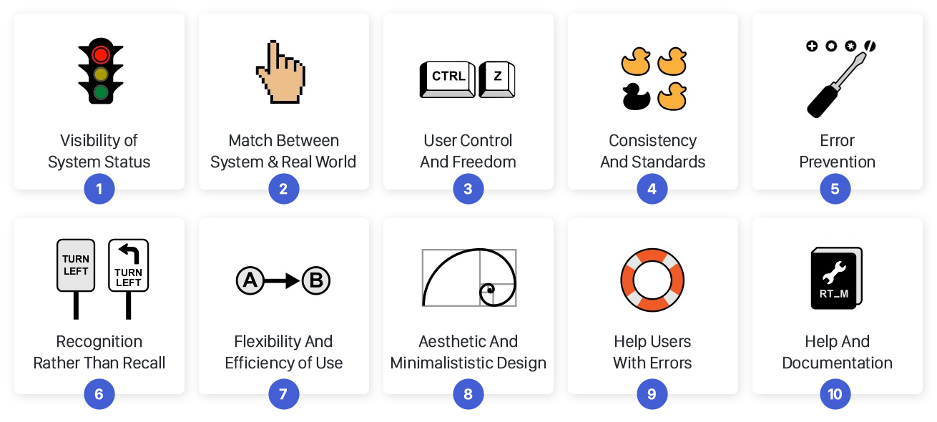

**Twitter:** making a sound when a tweet is posted.

**Think aloud**

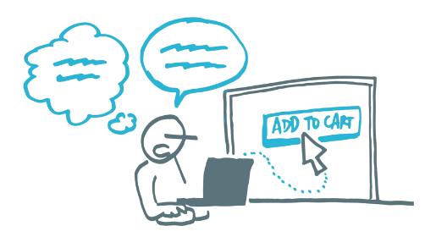

When a development of an interface is being planned.

**Cognitive walkthrough**

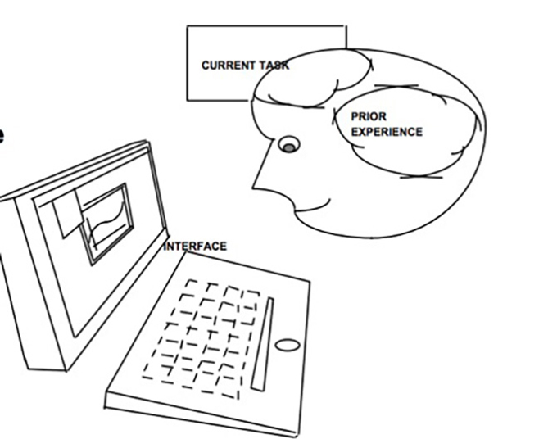

A person using a module of a system to be developed

**Questionnaires**



To measure how satisfied you are with the system you just used (Game, app, software)

**Clickstreams**

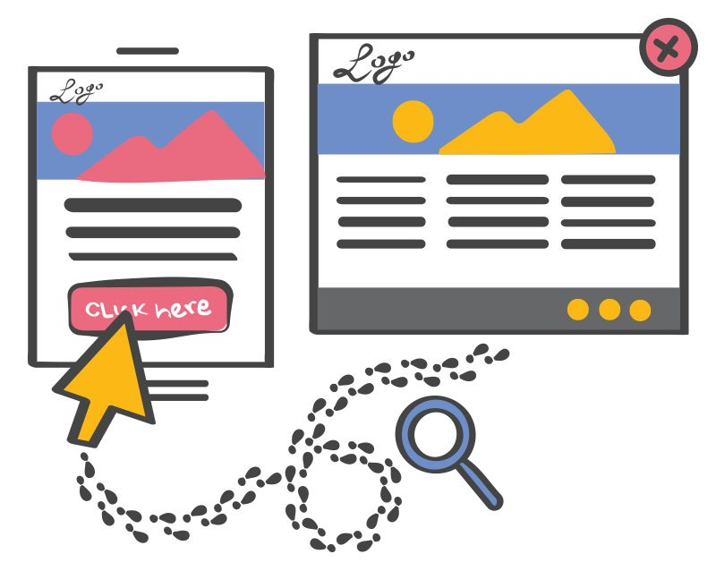

To analyze which are the least traveled by users and thus improve the user experience

**Eye tracking**

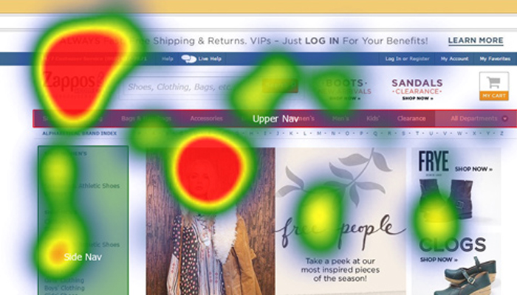

To determine which sections of our page receive more attention from users.